How to Add/Edit Events

Step 1.
- Go to touchingheart.com/admin/
- username: Helen.Yi password: Helen2012
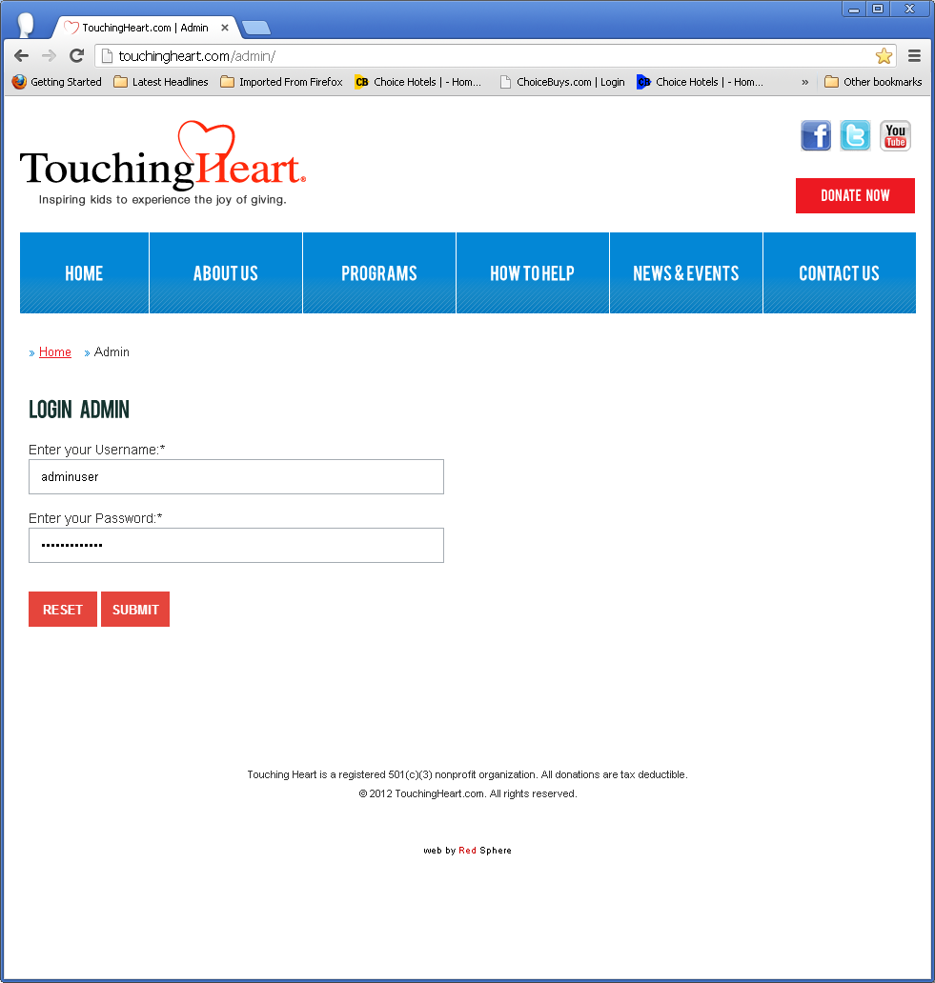
Figure 1

Step 2.
once you are logged in, scroll down and navigate thru to the Main menu to the section where you want to edit or add something, in this case News & Events. (Figure 2)
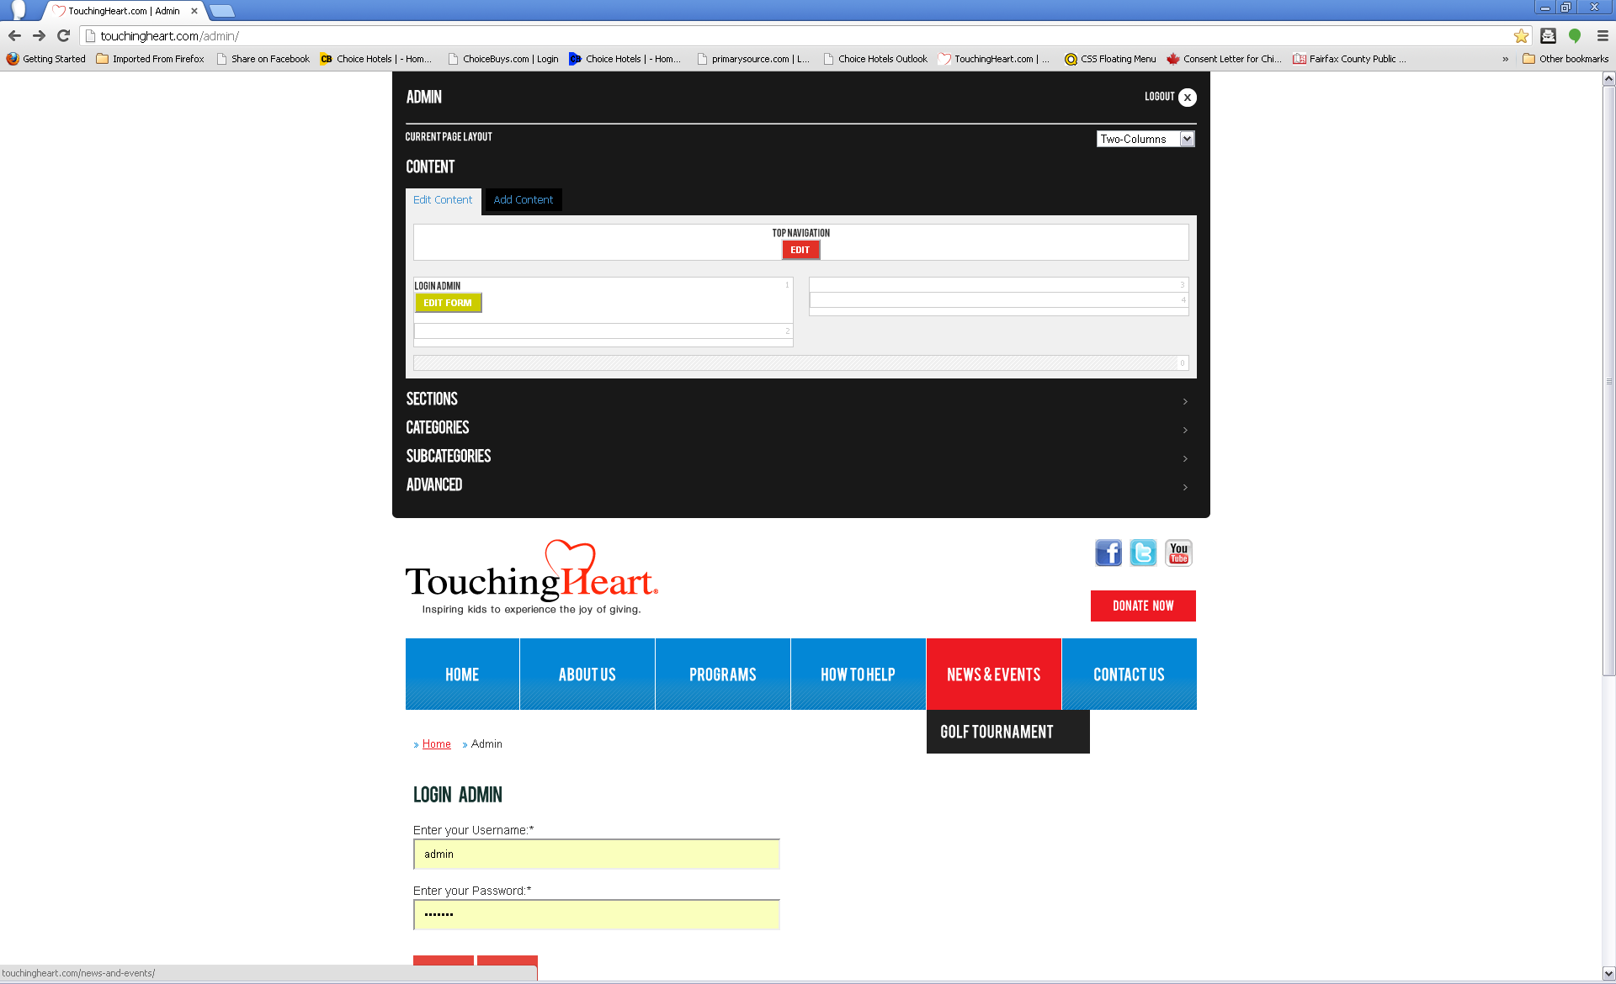
Figure 2

Step 3.

Edit
To Edit an Event, press the relevant button “edit event”. (Figure 3)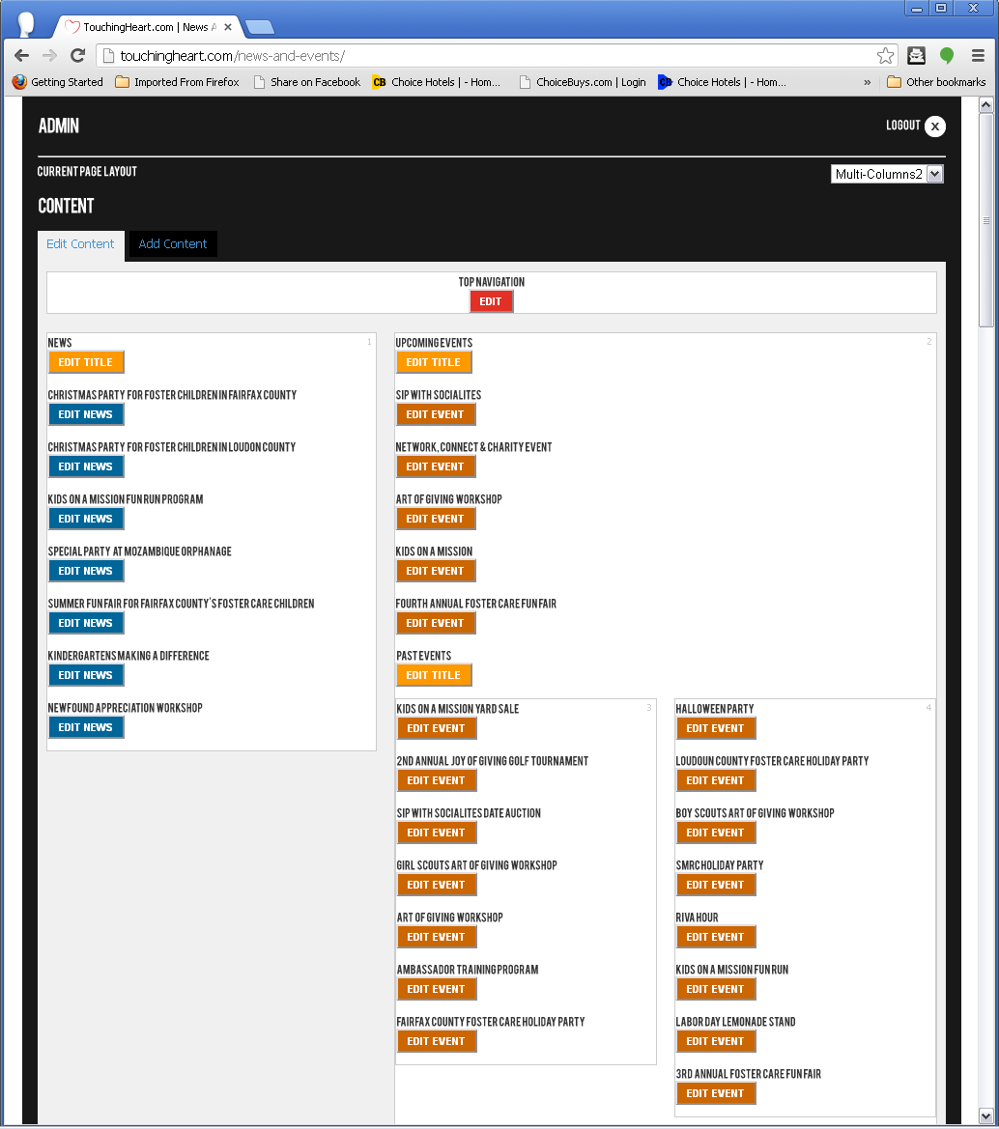
Figure 3

Initially, you are presented with the following options: (Figure 5)
Title: Note that the title you choose will also be part of the url. Be as specific as possible.
Short Description: Introduction Paragraph.
Long Description: Content Paragraphs. If content is added here, the Short Description will have a “Read More” button. (Figure 4)
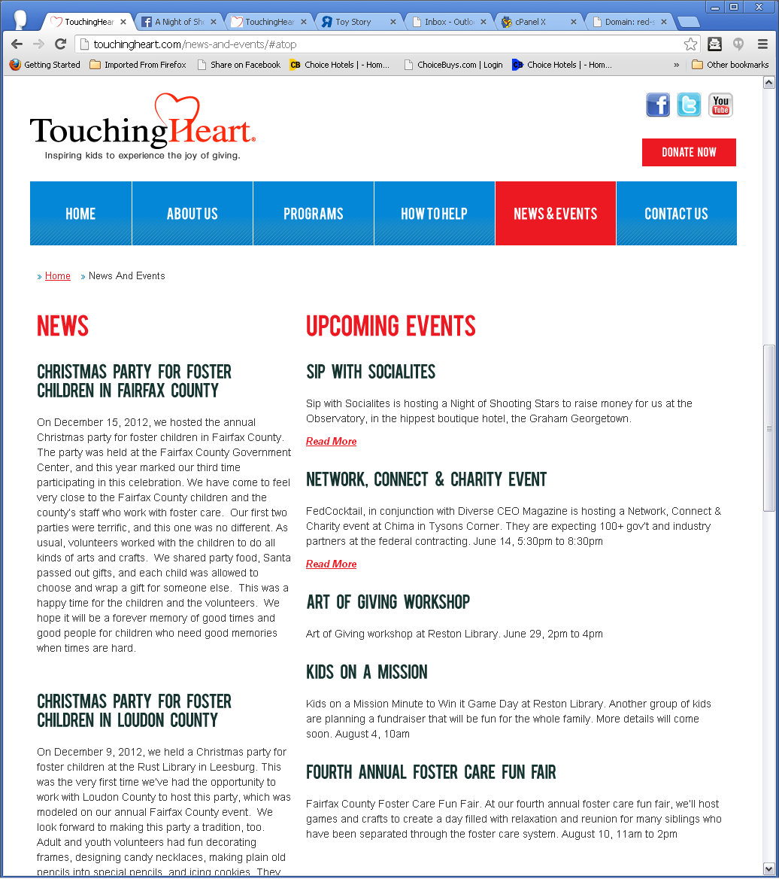
Figure 4
Layout position: There are 5 available positions on every page (0-4). To hide an Event just set the Layout position to 0 (zero). Refer to “Current Page Layout”.
Position order: This is the order within the page position. Default value is 0.
Home Featured: If you want to have this event presented in the homepage content area, check this box.

To add a Banner, images, external link, start date, expiration date, or advanced options click “More”. Otherwise just click “Save”.
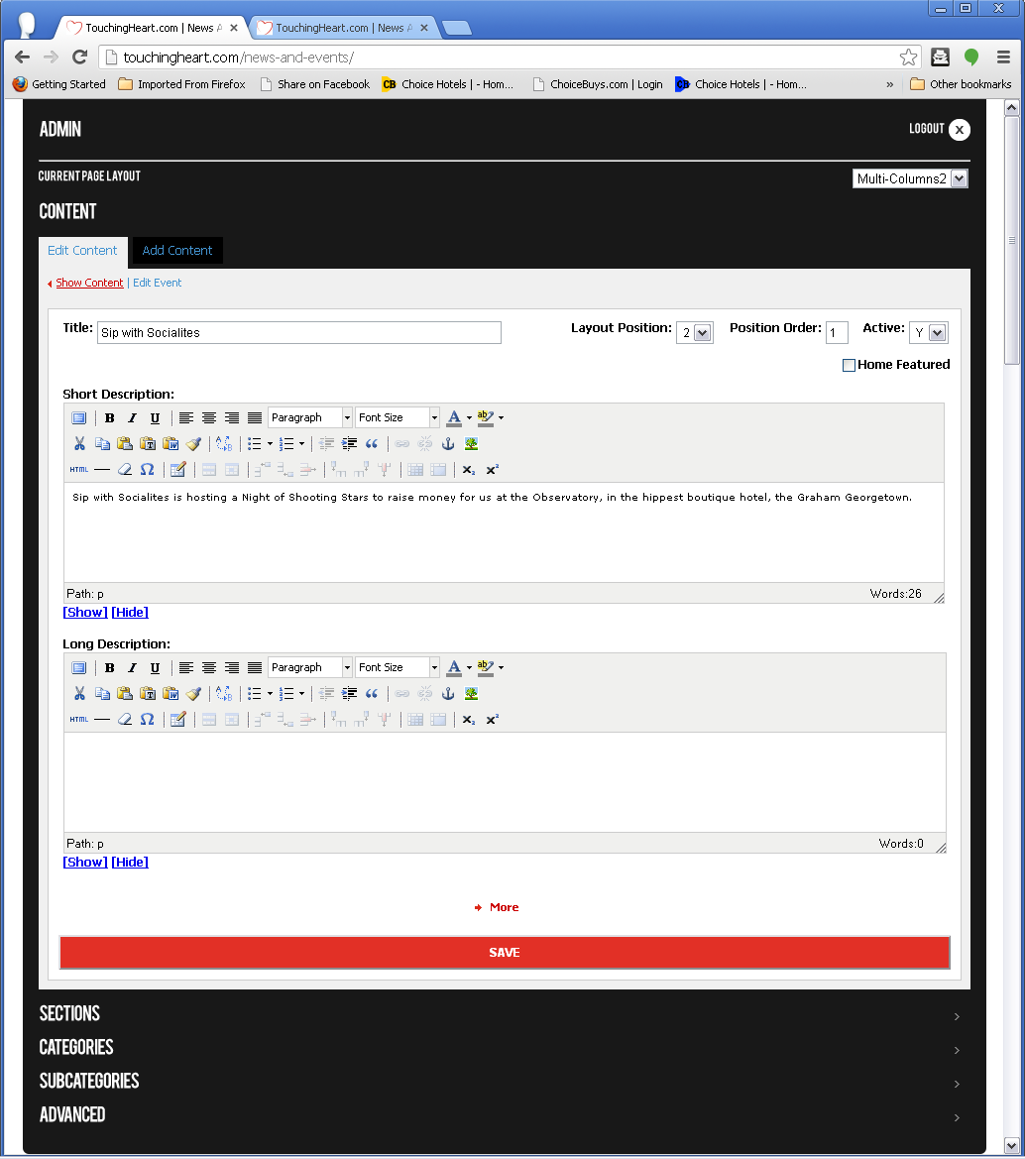
Figure 5

Expand “More”, to find the following options: (Figure 6)
Link & Open blank. Please note that any link you add here will prevail over the Long Description.
Feature Picture: This is the homepage banner. The system will automatically resize the banner to fit in 940 width x 284 height px.
Small Picture: This is the picture that goes with the Short Description. It is automatically resized depending on the layout position and Pict. Alignment.
Article Picture: This is the picture that goes on the landing page of the event. It is automatically resized depending on the layout position and Pict. Alignment.
Start and expiration Date: To add a start date (show the event on a specific date in the future) or expiration date (hide event on specific date), just complete the boxes in the following format: yyyy-mm-dd hh:mm:ss. Initial values of zeroes means infinite.
Article Location (advanced): To move this event to another page modify as necessary.
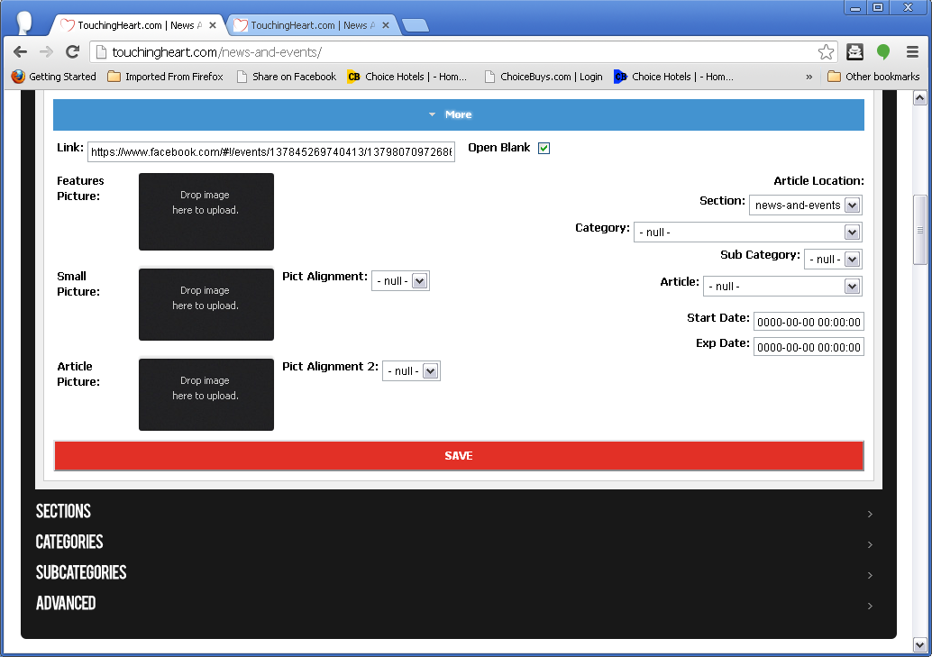
Figure 6
To finish click ”Save”.

Add
To add an event, press the “Add Content” button, and then click on “Event”:
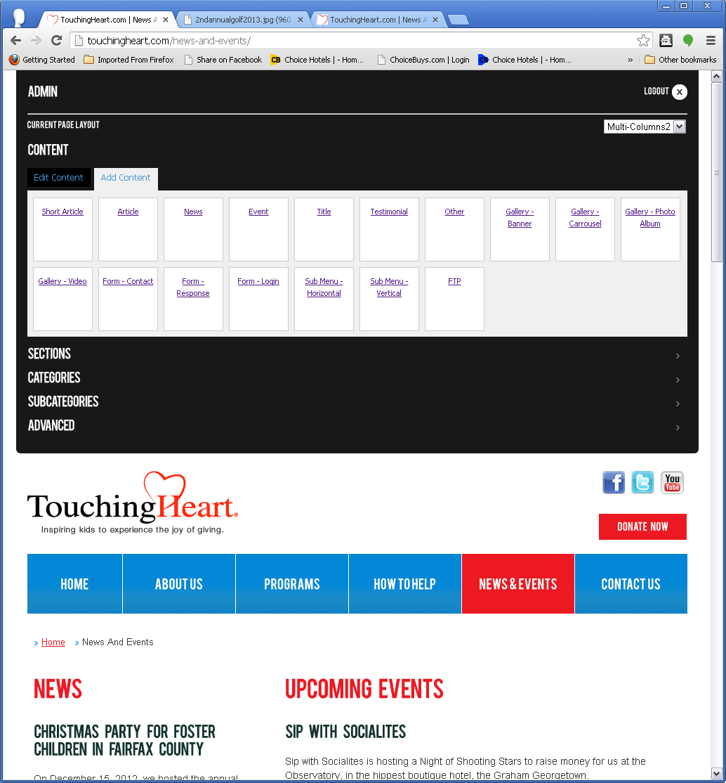
Figure 7

Initially, you are presented with the following options:
Title: Note that the title you choose will also be part of the url. Be as specific as possible.
Short Description: Introduction Paragraph.
Long Description: Content Paragraphs. If content is added here, the Short Description will have a “Read More” button. (Figure 4)

Figure 8
Layout position: There are 5 available positions on every page (0-4). To hide an Event just set the Layout position to 0 (zero). Refer to “Current Page Layout”.
Position order: This is the order within the page position. Default value is 0.
Home Featured: If you want to have this event presented in the homepage content area, check this box.

To add a Banner, images, external link, start date, expiration date, or advanced options click “More”. Otherwise just click “Save”.

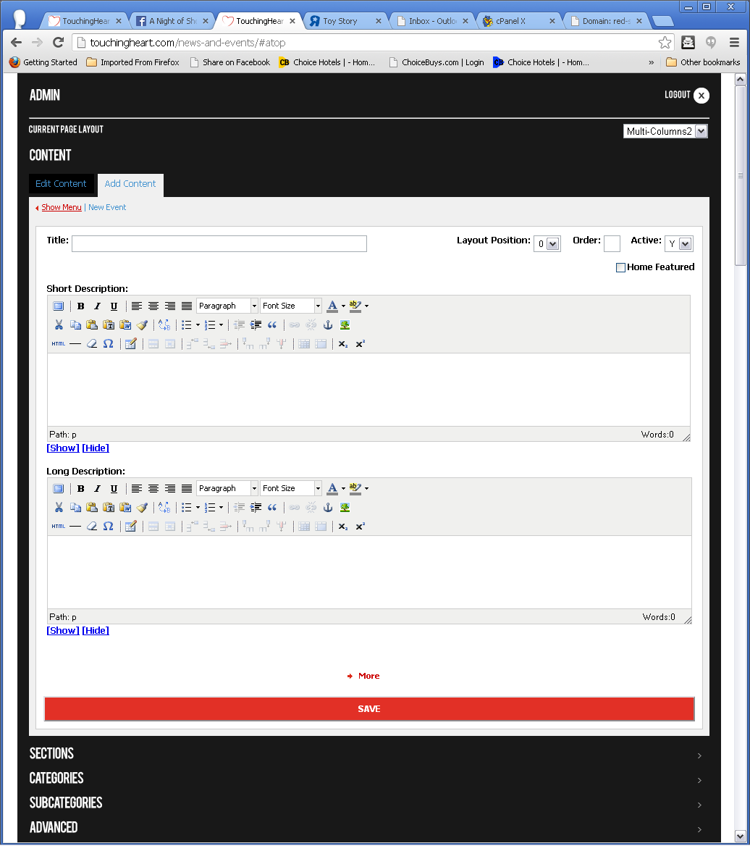
Figure 9

Expand “More”, to find the following options: (Figure 10)
Link & Open blank. Please note that any link you add here will prevail over the Long Description.
Feature Picture: This is the homepage banner. The system will automatically resize the banner to fit in 940 width x 284 height px.
Small Picture: This is the picture that goes with the Short Description. It is automatically resized depending on the layout position and Pict. Alignment.
Article Picture: This is the picture that goes on the landing page of the event. It is automatically resized depending on the layout position and Pict. Alignment.
Start and expiration Date: To add a start date (show the event on a specific date in the future) or expiration date (hide event on specific date), just complete the boxes in the following format: yyyy-mm-dd hh:mm:ss. Initial values of zeroes means infinite.
Article Location (advanced): To move this event to another page modify as necessary.
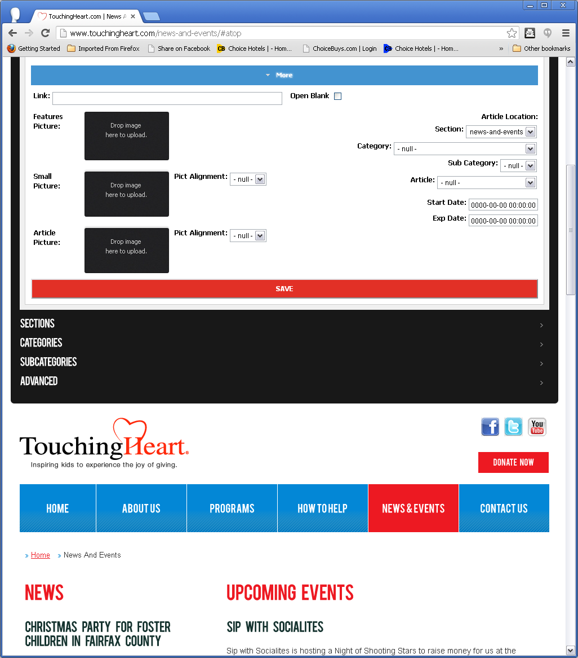
Figure 10

